

[](http://www.adis.bg/bg/) [header_r1_c1](http://www.comfort.bg/bg/public/index.php)

[www.comfort.bg](http://www.comfort.bg)

 ИЗПЪЛНИТЕЛНА АГЕНЦИЯ ЗА НАСЪРЧАВАНЕ НА МАЛКИТЕ И СРЕДНИТЕ ПРЕДПРИЯТИЯ

[www.asme.bg](http://www.asme.bg)

[](http://www.investor.bg/) [logo_nCD](http://www.allianz.com/)

[www.allianz.com](http://www.allianz.com)

**ALBENA 2000** [**www.investor.bg**](http://www.investor.bg)

[](http://www.aebtri.com/Default.aspx)

[www.aebtri.com](http://www.aebtri.com)

[2-1_logo](http://www.accbg.com/index.php?lang=bg) [**www.all-channels.com**](http://www.accbg.com/www.all-channels.com)

 [АЕЦ Козлодуй](http://www.kznpp.org/main_en.php) [www.kznpp.org](http://www.kznpp.org)

[www.alenmak.bg](http://www.alenmak.bg)

**[trans](http://72.9.104.250/aromaen/index.php?lg=bg&ok=1&PHPSESSID=66d2a3063d515635c7b6074cb40008f6)**

[logo_club](http://www.aroma-bg.com/club_aroma/index.php)[**www.aroma-bg.com**](http://www.aroma-bg.com)

[](http://www.asarel.com/) **Air links Airport Centre Communication**

[**www.asarel.com**](http://www.asarel.com)

**trans**

Ara_Logo

[www.aramex.com](http://www.aramex.com)

 [www.bagra.net](http://www.bagra.net)

**BALKANPHARMA**

[www.actavis.bg](http://www.actavis.bg)

 Bank Biochim - home [www.biochim.com](http://www.biochim.com)

 **HEBROSBANK**

[www.hebros.bg](http://www.hebros.bg)

[www.bsbg.net](http://www.bsbg.net)

[logo](http://www.bsbg.net/)

[](http://www.billa.bg/)

[www.billa.bg](http://www.billa.bg)

 [www.sfb.bia-bg.com](http://www.sfb.bia-bg.com) [www.sunoil-bg.org](http://www.sunoil-bg.org)

**BISER OLIVA JSC**

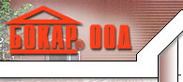

[www.bokar.bgcatalog.com](http://www.bokar.bgcatalog.com)

 logo_bno

[www.bn-outdoor.com](http://www.bn-outdoor.com) Balkan News Outdoor



[www.btv.bg](http://www.btv.bg)

**Balkan News Corporation**

**bTV**

[](http://www.unisoft.bg/index.htm)[www.unisoft.bg](http://www.unisoft.bg)

**BALKAN YES TEAM** EOOD



[www.biomeda.net](http://www.biomeda.net)

BTC-NET

[www.btc-net.bg](http://www.btc-net.bg)

[www.bulgariatherm.com](http://www.bulgariatherm.com)



[www.bulsaprint.com](http://www.bulsaprint.com)

[](http://www.bulstrad.bg/bg/)

[www.bulstrad.bg/bg](http://www.bulstrad.bg/bg)



[www.bultex-bg.com](http://www.bultex-bg.com)

logo1

[www.bulgarskiimoti.bg](http://www.bulgarskiimoti.bg)

[www.postbank.bg](http://www.postbank.bg)



**Kraft Foods Bulgaria** [Kraft](http://www.kraft.com/index.html)  [www.kraft.com](http://www.kraft.com)

[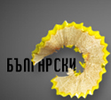](javascript:openwindow();) Kres Advertising Agency Kres

[www.kres.com](http://www.kres.com)



[www.liliahiv.com](http://www.liliahiv.com)

**Lowe Lintas Swing Communication  
Sofia – Bulgaria**

[www.unece.org](http://www.unece.org)



**[METRO Group – The Spirit of Commerce](http://www.metrogroup.de/)**

[**www.metro.bg**](http://www.metro.bg)

[](http://www.suzuki.bg/company.html)

[Mitsubishi Corporation](http://www.mitsubishicorp.com/en/index.html)

BULGARIA

[www.mitsubishicorp.com](http://www.mitsubishicorp.com)

[**www.suzuki.bg**](http://www.suzuki.bg)

**BUILDING MMG Ltd.**

**Real Estate in Bulgaria**

[www.europerealestatedirectory.net](http://www.europerealestatedirectory.net)

[**www.mtel.net**](http://www.mtel.net)

[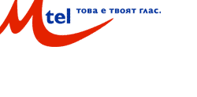](http://www.mtel.net/index.php?sid=a4ac9e28b88f83d9feebe36d721ef372&)

Coat REPUBLIC OF BULGARIA [www.nsi.bg](http://www.nsi.bg)

***NATIONAL STATISTICAL INSTITUTE***

[www.ogilvy.bg](http://www.ogilvy.bg)

 ***Ogilvy and Mather Advertising BULGARIA***

logosfb.bia-bg.com

Орбилекс ООД – София



[www.orgachim.bg](http://www.orgachim.bg)

**Pharmacy-Sofia**

 [www.sofia-life.com](http://www.sofia-life.com)

[**www.fair.bg**](http://www.fair.bg)

**International Fair - Plovdiv**

[](http://www.fair.bg/bg/vp/)

[](http://www.prista-oil.com/index.html?p=intro&l=bg)

[www.prista-oil.com](http://www.prista-oil.com)



[www.procreditbank.bg](http://www.procreditbank.bg)

Radisson SAS

[www.sofia.radissonsas.com](http://www.sofia.radissonsas.com)

REFAN BG Ltd.

[](http://www.refan.net/)

[www.refan.net](http://www.refan.net)



[www.refrachem.market.bg](http://www.refrachem.market.bg)

**Rocca BG**

www.furnish.bg 

 

[www.bulgaria.domino.bg](http://www.bulgaria.domino.bg)

[www.rodina-popovo.bg](http://www.rodina-popovo.bg)



 [www.mtc.government.bg](http://www.mtc.government.bg)

Vamo JSC - Varna

[www.sfb.bia-bg.com](http://www.sfb.bia-bg.com)

**Vitavel JSC – Lukovit**

[www.sfb.bia-bg.com](http://www.sfb.bia-bg.com)



[www.victoriaunique.com](http://www.victoriaunique.com)

**VINPROM PESHTERA AD**

[**www.peshtera.com**](http://www.peshtera.com)

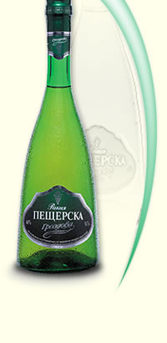

[www.**cabletel**.**bg**](http://www.cabletel.bg)

[www.care-bg.org ](http://www.care-bg.org/bg/indexbg.php)

[](http://www.cisco.com/)

## [Cisco systems Inc](http://www.cisco.com/).

[www.cisco.com](http://www.cisco.com)

**COCA COLA**



[**www.coca-colahbc.com**](http://www.coca-colahbc.com)

[](http://www.colliers.com/Markets/Bulgaria/)

[www.colliers.com](http://www.colliers.com)

[**Cosmo Bulgaria Mobile EAD (GLOBUL)** ](http://www.gsmworld.com/index.shtml) [www.gsmworld.com](http://www.gsmworld.com)



[www.deroni.com](http://www.deroni.com)

[dhl_logo](http://www.dhl-usa.com/home/Home.asp)[www.dhl.com](http://www.dhl.com)

**D H L International EOOD Bulgaria**

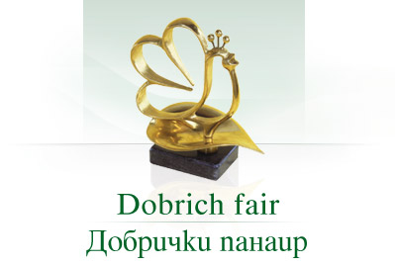

[www.dobrich-fair.com](http://www.dobrich-fair.com)

**DOMINION GRAIN BULGARIA AD**

logo_ep_text

[www.europrint-bg.com](http://www.europrint-bg.com)



[www.elana.net](http://www.elana.net)

**Enicomp**

Каталог "Архитектура и строителство" **ЛИА**



[www.eurospeed.biz](http://www.eurospeed.biz)

[[Zhiti.com](http://www.zhiti.com/) Zhiti.com](http://www.zhiti.com/) **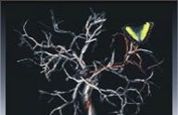** [Zhiti.com](http://www.zhiti.com/) ЖИТИ АД [www.zhiti.com](http://www.zhiti.com)

**Zebra JSC - Novi Iskar**

[www.beis.bia-bg.com](http://www.beis.bia-bg.com)

## Inter-Bg-Com Ltd.

[www.ripe.net](http://www.ripe.net)

showimg

[www.intracombg.com](http://www.intracombg.com)

**Сами-M**

***S* *andra***

**Hotels & Restaurant Equipment**

[**www.sandra-bg.com**](http://www.sandra-bg.com)

[logo](http://www.miningandconstruction.sandvik.com/sandvik/0120/Internet/Global/S003715.nsf)**SANDVIK BG**

Schenker_logo

[**www.schenker.bg**](http://www.schenker.bg)

Shell logoSHELL Bulgaria Ltd. [www.shell.com](http://www.shell.com)

siteident_1382579 Siemens

[**www.siemens.bg**](http://www.siemens.bg)

 [www.sisindustries.bg](http://www.sisindustries.bg)

scorpion

**SCORPION SHIPPING Ltd.** [**www.nsbs.bg**](http://www.nsbs.bg)

logo_index

[www.sopharma.bg](http://www.sopharma.bg)



[www.sofiyskavoda.bg](http://www.sofiyskavoda.bg)

[[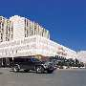](http://www.all-hotels.com/xbook/servlet/hotel-details?landing=true&hotl_id=265795##)](http://www.all-hotels.com/xbook/servlet/hotel-details?landing=true&hotl_id=265795##)

**Sofia Princess Hotel**



**SofstoCk-LavazZa Ltd**

[**www.bgfashion.net**](http://www.bgfashion.net)

[](http://www.solid55.com/)

[www.solid55.com](http://www.solid55.com)

www.stroy-consult.com 

[](http://www.swedishmatch.com/Eng/FirstPage_fp.asp) **Swedish Match PLAM BULGARIA**

[www.swedishmatch.com](http://www.google.com/search?hl=en&lr=&q=+site:www.swedishmatch.com+Swedish+match+bulgaria)

**THALLODERMA CO. LTD., PHARMACEUTICAL LABORATORIES** [www.chambersz.com](http://www.chambersz.com)

**TANDEM**

[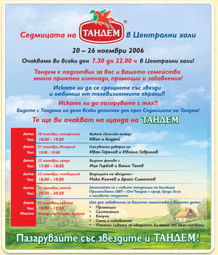](http://www.tandem.bg/img/index.jpg)

[www.tandem.bg](http://www.tandem.bg)

tbwa.gif

TBWA International Holding

[**Teletek Group** Holding, **Bulgaria** Teletek Logo](http://www.teletek-electronics.com/en/) [www.**teletek**-electronics.com](http://www.teletek-electronics.com)

[](http://www.tmf-group.com/index.php?PHPSESSID=1b11644ac58e1bd5d324b8d31b747aff)

**TMF International Bulgaria**

logoDuropak - Trakia Papir JSC - Pazardzhik

[www.beis.bia-bg.com](http://www.beis.bia-bg.com)

logo**WEB GATE**[www.beis.bia-bg.com](http://www.beis.bia-bg.com)

[](http://www.unipharm.bg/home.html)

[www.unipharm.bg](http://www.unipharm.bg)

## [Cumerio Med JSC - Pirdop](http://beis.bia-bg.com/index.php?lang=en&p=shortp&selcomp=1018)

unioms_logo

[www.unicoms.bg](http://www.unicoms.bg)

**[](http://www.unionbank.bg/index.php?p=home&language=bg&PHPSESSID=c737359002194852f7ec39bcc7ff2edf)**

[www.unionbank.bg](http://www.unionbank.bg)

[**www.beis.bia-bg.com**](http://www.beis.bia-bg.com)

**Unipharm JSC – Sofia**

[logo](http://www.usis-bg.com/index.html)

[www.usis-bg.com](http://www.usis-bg.com)

**ais**

**Финтехмаш АД**

[www.club9000.org](http://www.club9000.org/)

 [www.florina.bg](http://www.florina.bg)

[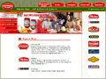](http://www.hermesfoods.com/)[www.prodigy-ltd.com](http://www.prodigy-ltd.com)

**Hermes Commerce Ltd.**

Шотерон

[www.tents-bg.com](http://www.tents-bg.com)

***WS Teleshop*** International FOOD

**HERTI**

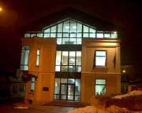

[www.herti.bg](http://www.herti.bg)

**Хайпро** – **България** **ООД**

 **CIELA** Soft&Publishing AD

[www.undp.bg](http://www.undp.bg) [www.bluelink.net](http://www.bluelink.net)

**XEROX BG** [www.xerox.com](http://www.xerox.com)

[ 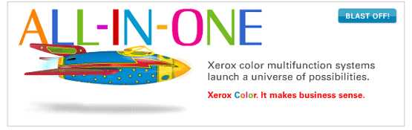](http://www.promo.xerox.com/accipiter/adclick/CID=000000706c6818a900000000/acc_random=14370393/SITE=XCOM/AREA=XCOM_HOMEPAGE/AAMSZ=555x175/COUNTRY=USA/XLANGUAGE=en_US/pageid=84191984)

[Zurück zur Startseite](http://www.evn.bg/de/index.asp) [www.evn.bg](http://www.evn.bg)

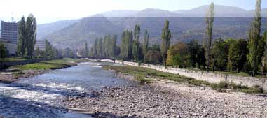

logoblueR

[**www.taxback.bg**](http://www.taxback.bg)

 [logo_w](http://www.omv.bg/) [www.omv.bg](http://www.omv.bg)

cloudani

[www.overgas.bg](http://www.overgas.bg)**[LogoOvergasEN](http://www.overgas.bg/index.jsp)**

**[](http://www.overgas.bg/Page.jsp?language=En&rootunid=94C47EC09199A885C2256FB1005FCC3B&unid=94C47EC09199A885C2256FB1005FCC3B) DATA PROCESSING** [www.aiidatapro.com](http://www.aiidatapro.com)

 [www.see-news.com](http://www.see-news.com)

**APOLO THE BEST EQUIPMENT**

[www.apolo-bg.com](http://www.apolo-bg.com)

 **ARGOS PRIMA Ltd.**

[**www.icpcredit.com**](http://www.icpcredit.com) **ATL – 50 Ltd** [www.atl-50.com](http://www.atl-50.com)

**ATICO INTERNATIONAL LTD**

[www.areon-fresh.com](http://www.areon-fresh.com)



AREON Fresh

**Balev Ltd Industrial Design**

### [head1a](http://www.sofia.bg/en/index_en.asp) [www.sofia.bg](http://www.sofia.bg)

### Sofia Municipal Privatisation Agency

 

[www.cryoinvest.com](http://www.cryoinvest.com)

logo[www.csc-bg.com](http://www.csc-bg.com)



**CSC Pharmaceuticals Ltd – Bulgaria EOOD**

[www.dmclima.com](http://www.dmclima.com)

**[](http://www.danspharma.com/about.html)**

**Danspharma Ltd.**

[www.danspharma.com](http://www.danspharma.com)

 [www.debatin-bg.com](http://www.debatin-bg.com)

**Diavach Ltd**

[www.diavach-bg.com](http://www.diavach-bg.com)[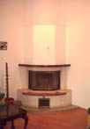](javascript:openWin('Diavach563p.jpg')) [](http://www.tradeleads.at/index.php)

[www.diavena.com](http://www.diavena.com)

**Diavena Ltd.**

[www.dmtravel.bg](http://www.dmtravel.bg)

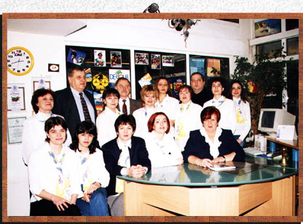[](http://www.dmtravel.bg/dmtravel/first.htm)**DM TRAVEL" Ltd**

**ELECTRON PROGRESS AD**

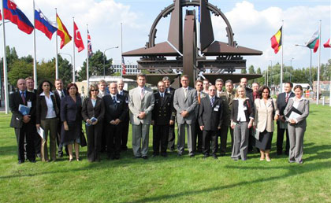

[www.eprogress.bg](http://www.eprogress.bg)

**The Nonferrous Metals Smelter**

[](http://www.kcm.bg/eng/index.html)**KCM 2000 SA**

[www.kcm2000.bg](http://www.kcm2000.bg)

[www.elmot.dir.bg](http://www.elmot.dir.bg)



[www.ema-bg.com](http://www.ema-bg.com)



***ЕМОНИЯ ФАРМАТЕХ*** [www.emmonya.com](http://www.emmonya.com)

[](http://www.enicomp.com/index.php)

[www.enicomp.com](http://www.enicomp.com)

## [EPIQ - the electronic system manufacturer world-wide](http://www.epiq.com/)

[www.epiq.com](http://www.epiq.com)



[www.eskana.com](http://www.eskana.com)

**Esteri Ltd.** [www.esteri-bg.com](http://www.esteri-bg.com)

**ETICOM LTD Petrich**

[www.eticom.bg](http://www.eticom.bg)

logo1 logo_animM [www.evricom.bg](http://www.evricom.bg)

header_en

fadata  [www.fadata.bg](http://www.fadata.bg)

**Finansial Supervision Commission** gerb

[www.fsc.bg](http://www.fsc.bg)

[](http://www.fincombg.com/?81&01&92)

[www.fincombg.com](http://www.fincombg.com)

[www.florex-bg.com](http://www.florex-bg.com)

head_r4_c2 head_r4_c8

**Fortes JSC**

[www.fortes.bg](http://www.fortes.bg)

FREEZONE ROUSE

[www.freezone-rousse.bg](http://www.freezone-rousse.bg)

[](http://www.teambulgaria.com/)

Free Trade Zone JSC Burgas

[www.escapetobulgaria.com](http://www.escapetobulgaria.com)

 3 w[www.gimel.bg](http://www.gimel.bg)

**Han Omurtag JSC**

**Han Asparuh JSC**

**HAYAT BG** [finance.news.bg](http://www.stockmarket.bg/) [www.stockmarket.bg](http://www.stockmarket.bg)

**HIDCOM**, Bulgaria,

 logohiltan2 [www.hiltan.hit.bg](http://www.hiltan.hit.bg) [www.hayatbg.com](http://www.hayatbg.com)

logo_big_2

[www.bulgariaholding.com](http://www.bulgariaholding.com)

 **Industrial Holding Bulgaria JSC**

[www.industrial-parts.com](http://www.industrial-parts.com)

**ИНДУСТРИАЛТЕХНИК АД**

[www.indtechnic.com](http://www.indtechnic.com)

[Информационно обслужване АД](http://www.is-bg.net/site_io/?&PHPSESSID=c16c0193b94aa6e41eeef19148500f65)

[www.is-bg.net](http://www.is-bg.net)

[logo](http://www.comtradegroup.com/default.aspx)

**International Business Centre** *Vassilev Plaza*

[www.comtradegroup.com](http://www.comtradegroup.com)

irm_logo

insider_logo **International Resource Management**

[www.i-r-m.com](http://www.i-r-m.com)

***International Transport and Travelling*** Sofia Ltd.

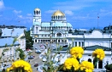

[www.**sofia**-travelagencies.inn26.com](http://www.sofia-travelagencies.inn26.com)

[www.inpris.com](http://www.inpris.com)

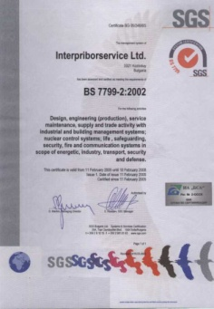

**Interpriborservice Ltd.**

index_02 index_03

[www.ipoma.com](http://www.ipoma.com)

[](http://www.cafeflamingo.com/) **Ivory Stone Co Ltd.**

[www.cafeflamingo.com](http://www.cafeflamingo.com)

***Jano Ltd.***

[*www.jano.bg*](http://www.jano.bg)

***Kagami* Ltd.** [www.kagami.bg](http://www.kagami.bg)

**Karstad** *Quelle International services Ltd***.**

[www.karstadquelle.com](http://www.karstadquelle.com)

kittner1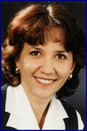

[www.kittnerbg.com](http://www.kittnerbg.com)

### Kolev & Kolev

### Definitive Bulgarian children's shoes

[www.kolevikolev.com](http://www.kolevikolev.com)

Mac Cap Nishava JSC[www.maccup.bg](http://www.maccup.bg)



[www.meggle.bg](http://www.meggle.bg)

 

[www.minedu.government.bg](http://www.minedu.government.bg)

Miti Lom Ltd**.** www.[miti.net](mailto:miti@almus.net)

[www.mmg.bg](http://www.mmg.bg)

**/** ****

[www.nikabg.com](http://www.nikabg.com)

**[](http://www.mtc.government.bg/index.php) Изпълнителна агенция МОРСКА АДМИНИСТРАЦИЯ**

[www.mtc.government.bg](http://www.mtc.government.bg)

logo

[www.moststroy.com](http://www.moststroy.com)

logo**Mraz JSC** [**www.sfb.bia-bg.com**](http://www.sfb.bia-bg.com)

 **НАЦИОНАЛНАТА ЗДРАВНООСИГУРИТЕЛНА КАСА**

[www.nhif.bg](http://www.nhif.bg)



[www.ozontlaser.com](http://www.ozontlaser.com)

 *PALOMITA*

[www.palomita.com](http://www.palomita.com)

## [PATENT OFFICE OF THE REPUBLIC OF BULGARIA](http://www.bpo.bg/en/conception_IP.html)

[www.bpo.bg](http://www.bpo.bg)

upleft upleft2

[www.fomus.com](http://www.fomus.com)

[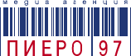](http://www.piero97.com/index.php) 

[www.piero97.com](http://www.piero97.com)



[www.piccadilly.bg](http://www.piccadilly.bg)

*Bulgartaback Holding* **Pleven –BT JSC** [www.beis.bia-bg.com](http://www.beis.bia-bg.com)

# Pontifices.org[www.pontifices.org](http://www.pontifices.org)

**Putinvest-engeneering JSC** [www.pie.bg](http://www.pie.bg)

[www.tracebg.com](http://www.tracebg.com)

deinosti_114

[www.rosiza.bg](http://www.rosiza.bg)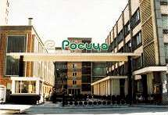

[](http://www.selecta.bg/index.html?PHPSESSID=a048a8bff7258579fa0708736c737984)

[www.selecta.bg](http://www.selecta.bg)

SEMA GROUP Ltd

[www.**sema**.co.uk](http://www.sema.co.uk)

logo [www.siltek.bg](http://www.siltek.bg)

**Siltek Engineering Ltd.**

[www.srednagora.com](http://www.srednagora.com)



**Stroitelna Mehanizatsia JSC –Kazanluk**

[www.stroimeh.bg](http://www.stroimeh.bg)

*LET, S BUILD FUTURE TOGETHER*

**Stroy-Consult Ltd.**

[www.stroy-consult.com](http://www.stroy-consult.com)

****www.sts.bg**home**

*STS Holding Group Industrial Design*

index_05

TEKOM [www.te.tekom.com](http://www.tekom.com)

[www.Teletek-group.bg](http://www.Teletek-group.bg)

[www.timeline.bg](http://www.timeline.bg)

* ***TIMEX* REX ROTARY**

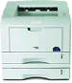

[www.timex.bg](http://www.timex.bg)

**Toner Direct Ltd.** [](http://tonerdirect.org/index.php?osCsid=306b4e7428bcc4dac31b263ac9850e84) [www.tonerdirect.org](http://www.tonerdirect.org)

transexpress [www.nsbs.bg](http://www.nsbs.bg)

 [www.uncinema.com](http://www.uncinema.com)

logo[www.ort-officefurniture.com](http://www.ort-officefurniture.com) 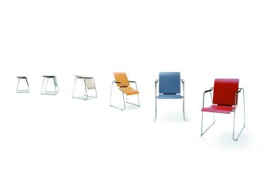

[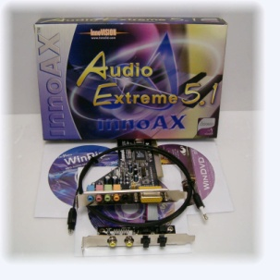](http://www.ivmm.com/)

**TORIN COMPUTERS** [www.torin.bg](http://www.torin.bg)